Graph Theory Fall 2020

Assignment 4

Due at 5:00 pm on Friday, September 25

1. **For the cube graph $Q_{n}$, the distance $D\left(a,b\right)$ between two vertices**

$$a=\left(a_{1},a_{2},…,a_{n}\right) \text{and} b=\left(b_{1},b_{2},…,b_{n}\right)$$

**is called the “Hamming distance.” This is the number of positions where $a$ and $b$ differ. For instance, the Hamming distance between $\left(0,0,1,0\right)$ and $\left(1,1,0,0\right)$ is 3 because these two vertices differ in three positions. In each of the parts A, B below, $D\left(x,y\right)$ is the Hamming distance in $Q_{n}$:**

1. **Show that if $D\left(a,b\right)$ and $D\left(b,c\right)$ have the same parity (i.e., are both even and are both odd), then $D\left(a,c\right)$ must be even.**
2. **Show that if $D\left(a,b\right)$ and $D\left(b,c\right)$ have different parity, then $D\left(a,c\right)$ must be odd.**
3. From the information given above, we can deduce that D (a, b) and D (b, c) have the same parity. It can be written as: $D\left(a,b\right)= \sum_{i}{a-b}$ = **Y** and $D\left(b,c\right)=\sum_{i}{b-c}$ = **Z**

Then $D\left(a,c\right)=(\sum_{i}{(a-b}$) – n) + (( $\sum_{i}{(b-c})$-n) = Y ***+ Z – 2n***

In the equation, as **Y and Z** share the same parity (even), then ***Y + Z – 2n*** will also be even.

1. In this question, D (a, b) = $\sum_{i}{a-b}$ = **Y** and D (b, c) = $\sum_{i}{a-b}$ = **Z.**

In this case, we are given that **Y** and **Z** do not have the same parity which will imply that **Y + Z =** odd. Therefore, **Y + Z -2n** will not be even.

1. 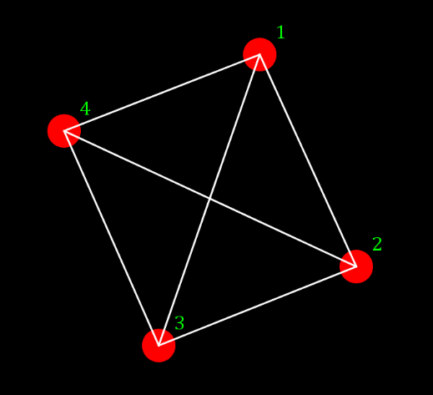**Consider $K_{4}$ as drawn and labeled below:**

**Since this graph is simple, we can specify a walk by listing only the vertices. For instance, $C:1,2,3,4,1$ is a 4-cycle; this can be abbreviated**

**as “12341”. List all of the cycles (abbreviated style is fine) that start and end at vertex 1 in this drawing of .**

1. C1 : 12341

C2: 14321

1. C3: 1341

C4: 1431

1. C7: 1231

C8: 1321

1. C5: 1241

C6: 1421

1. **For $1≤m≤11$, let $G_{m}$ be the graph with vertex set $$V=\left\{0,1,2,3,4,5,6,7,8,9,10,11\right\}$$**

**and where vertices $u$ and $w$ are adjacent iff $w-u=m$ modulo 12 or $u-w=m$ modulo 12. We observe that $G_{1}=C_{12}$, a twelve-cycle.**

1. **For what values of $m$ is $G_{m}$ connected?**
2. **What are the possible numbers of components of $G_{m}$?**
3. V = {0,1,2,3,4,5,6,7,8,9,10,11}

For m =1, the cycle we get is, 0-1-2-3-4-5-6-7-8-9-10-11. (connected)

For m =2, the cycle we get is, 0-2-4-6-8-10-0 and 1-3-5-7-9-11-1. Therefore, we have two disjoint cycles. (disconnected)

For m=3, the cycle we get is, 0-3-6-9-0, 1-4-7-10-1, 2-5-8-11-2. (disconnected)

For m=4, the cycle we get is, 0-4-8-0, 1-5-9-1, 2-6-10-2, 3-7-11-2. (disconnected)

For m=5, the cycle we get is, 0-5-10-3-8-1-6-11-4-9-2-7-0. As there is only one cycle, graph is connected.

For m=6, the cycle we get is, 0-6-0, 1-7-1, 2-8-2, 3-9-3, 4-10-4, 5-11-5,

For m=7, the cycle we get is, 0-7-2-9-4-11-6-1-8-3-10-5-0. One cycle (connected)

For m=8, the cycle we get is, 0-8-4-0, 1-9-5-1, 2-10-6-2, 3-11-7-3. (disconnected)

For m=9, the cycle we get is, 0-9-6-3-0, 1-10-7-4-1, 2-11-8-5-2. (disconnected)

For m=10, the cycle we get is, 0-10-8-6-4-2-0, 1-11-9-7-5-3-1. (disconnected)

For m=11, the cycle we get is, 0-11-10-9-8-7-6-5-4-3-2-1-0. (connected)

Therefore, the graph is connected for **m= (1,5,7,11)**

1. Possible numbers of components of Gm

|  |  |  |  |  |  |  |  |  |  |  |  |
| --- | --- | --- | --- | --- | --- | --- | --- | --- | --- | --- | --- |
| m | 1 | 2 | 3 | 4 | 5 | 6 | 7 | 8 | 9 | 10 | 11 |
| Possible numbers of components | 1 | 2 | 3 | 4 | 1 | 6 | 1 | 4 | 3 | 2 | 1 |

1. **Let $G$ be a graph and let $e_{1}$ and $e_{2}$ be edges. Show that if deleting $e_{1}$ and $e_{2}$ disconnects vertices $u$ and $v$, then any cycle containing both $u$ and $v$ must contain both $e_{1}$ and $e_{2}$. One approach: You could apply to the graphs $G-e_{1}$ and $G-e_{2}$ the fact that if $e$ is a bridge whose removal disconnects $u$ and $v$, then any path connecting $u$ and $v$ must contain $e$.**

From the given conditions above, e1 and e2 are both edges in the graph G. In the e1 edge, G graph will have two different constituents, we will take them as: G1 and G2.

The vertices of G1 and G2 be V (G1) and V (G2). If $u E V\left(G1\right)$ and $v E V(G2)$ where there is a path from u-v which does not have $e1$, that would imply that u-v are connected in $G-e1$. This becomes a contradiction as the G-e1 graph is connected. This inferences that e1 is has a u-v path.

As we know, there exists a path between u-v in the graph G which contain both e1 and e2 which concludes that a cycle that has u and v MUST have e1 and e2.